

Date as Received
Dear Customer,

With the 2024 festive season soon to be upon us, I would like to inform you of our opening hours during this time.

Monday 23rd December Open as Normal
Tuesday - Christmas Eve 24th December CLOSED
Wednesday - Christmas Day 25th December CLOSED
Thursday - Boxing Day 26th December CLOSED
Friday 27th December Open as Normal
Saturday 28th December Standard Weekend Cover
Sunday 29th December Standard Weekend Cover
Monday 30th December Open as Normal
Tuesday 31st December Open as Normal
Wednesday - Bank Holiday 1st January CLOSED
Thursday 2ndJanuary Open as Normal

Emergency Contact Numbers are:
Service: 07919 214 787
Stores: 07919 214789

May I also take this opportunity to Wish You A Very Merry Christmas, a prosperous New Year, and Thank You for your continued custom with us.

Best Wishes
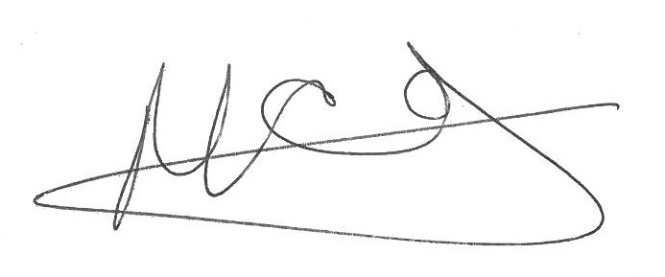
Matt Carse & all Staff

